|  |  |
| --- | --- |
| EGC_Black | Student Name \_\_\_\_\_\_\_\_\_\_\_\_\_\_\_\_\_\_\_\_\_\_\_    **Eastern Goldfields College**  Mathematics Essentials U3&4 2017  Test 11 |
| **Working Time: 55 minutes** | **Total Marks: 50 marks** |

**Show all working where necessary to maximize your marks.**

**Part A – No notes or calculator allowed**

**Question 1 (5 marks: 1, 1, 2, 1)**

1. What is 15% of $600

1. Write the missing numbers in this sequence:

5, 10.5, \_\_\_\_\_\_, 21.5, \_\_\_\_\_\_.

1. i. What is the difference pattern in the table below?

|  |  |  |  |  |  |  |
| --- | --- | --- | --- | --- | --- | --- |
| *x* | 0 | 1 | 2 | 3 | 4 | 5 |
| *y* | 100 | 89 | 78 | 67 | 56 | 45 |

ii. Describe a situation that this information might be related to.

d) A rule linking Cost (C) in $ to the number of people (P) is given as follows:

C = 25P + 350

What could the 350 represent in this context?

**Question 2 (3 marks: 1, 2)**

a) Given the four scatter graphs below, which one shows the weakest linear relationship?

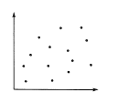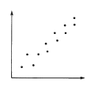 A B

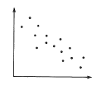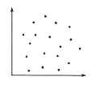

C D

b) Match each of the scatter graphs with one of these descriptions:

1. Sales of flyspray and the temperature Graph \_\_\_\_\_\_
2. Frequency of playing sport and fitness level Graph \_\_\_\_\_\_
3. Foot length and intelligence Graph \_\_\_\_\_\_
4. Test results and hours spent watching TV Graph \_\_\_\_\_\_

**Question 3 (5 marks)**

State the coordinates of each point.

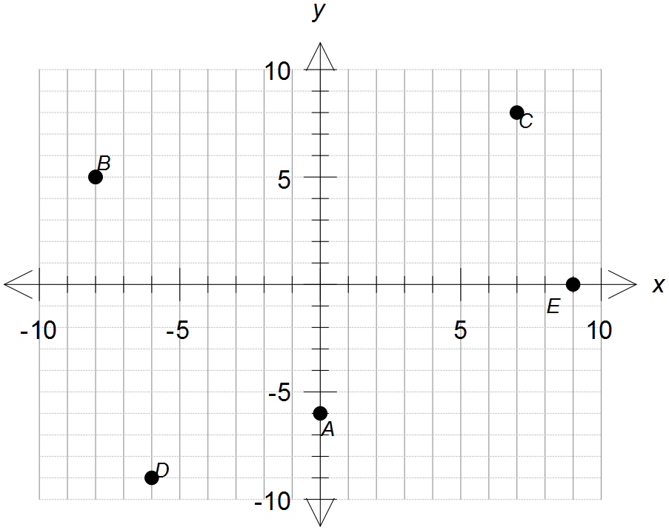

A

B

C

D

E

**Part B – Notes page and calculator permitted for this section**

**Question 4 (7 marks: 2, 1, 2, 2)**

Shane is paid a retainer (fixed amount when no sales are made) and a commission on the value of his sales. His work involves getting people to sign up for holidays.

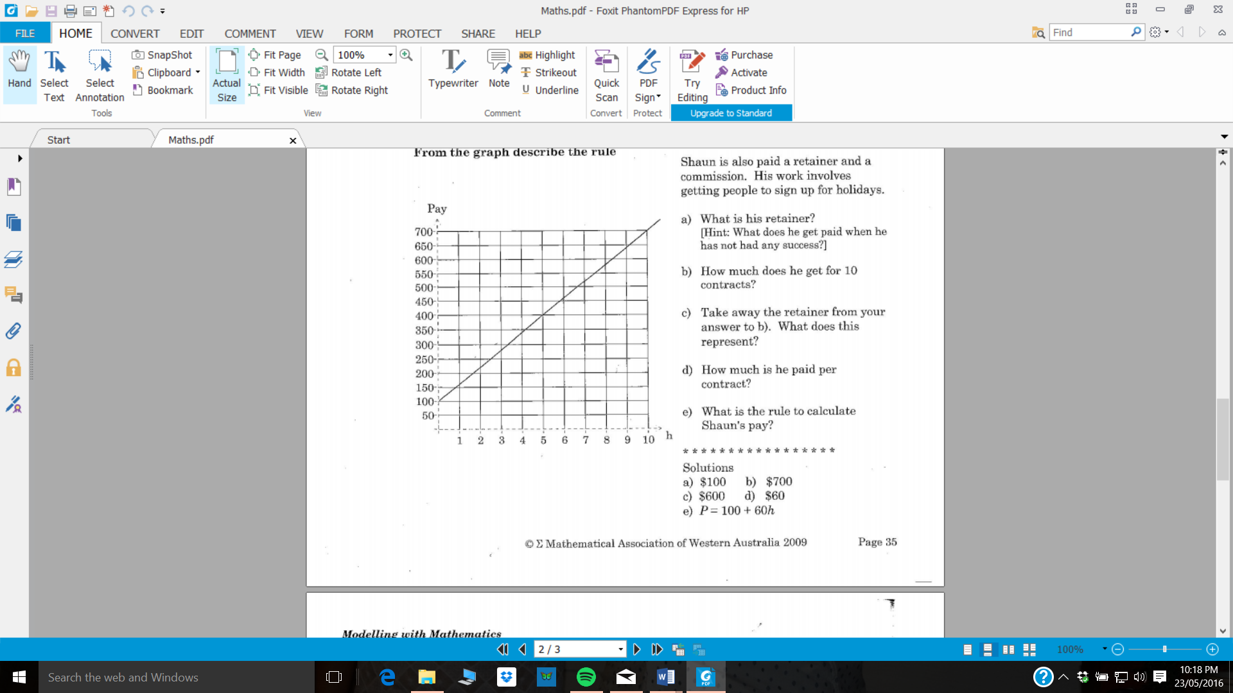

Number of Holidays

a) What is his retainer and what feature of the graph indicates this?

b) How much does he earn for 10 contracts?

c) What is the gradient of the line and what does this represent in the context of this situation?

d) What is the rule in terms of ‘h’ to calculate Shane’s pay (P)?

**Question 5 (5 marks: 1, 1, 2, 1)**

The diagrams below represent an arrangement of tables and chairs.

This is summarized in the table below.

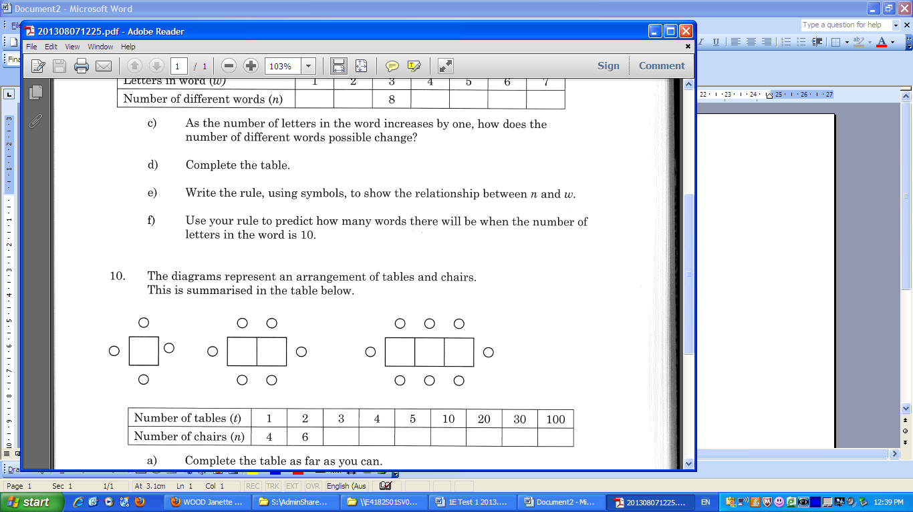

1. Draw the next diagram in the pattern.
2. Complete the table for values for t = 3 and t = 4.

|  |  |  |  |  |  |  |  |  |
| --- | --- | --- | --- | --- | --- | --- | --- | --- |
| Number of tables (t) | 1 | 2 | 3 | 4 | 5 | 10 | 20 | 100 |
| Number of chairs (n) | 4 | 6 |  |  |  |  |  |  |

c) Write a rule linking t and n

d) Complete the table above

**Question 6 (11 marks: 3, 1, 1, 2, 1, 2, 1)**

The table below shows the length and diameter of a small sample of bird eggs from different species of birds.

|  |  |  |  |  |  |  |  |  |  |  |  |  |  |  |  |
| --- | --- | --- | --- | --- | --- | --- | --- | --- | --- | --- | --- | --- | --- | --- | --- |
| length (mm) | 95 | 18 | 29 | 70 | 66 | 11 | 86 | 101 | 15 | 135 | 43 | 147 | 150 | 153 | 140 |
| diameter (mm) | 62 | 13 | 21 | 47 | 42 | 8 | 60 | 70 | 13 | 81 | 34 | 110 | 124 | 133 | 89 |

1. Construct a scatterplot for the data.



1. State the dependent and independent variables;

Dependent : \_\_\_\_\_\_\_\_\_\_\_\_\_\_\_\_ Independent : \_\_\_\_\_\_\_\_\_\_\_\_\_\_\_\_

1. Describe the relationship between length and diameter for the dataset.
2. Draw a line of best fit and use it to predict the diameter of an egg with a length of 50 mm
3. Predict the diameter of an egg with a length of 160 mm.
4. Which answer is likely to be more reliable/accurate – (d) or (e)? Explain why.
5. Describe the trend of the data.

**Question 7 (2 marks)**

The following graph shows the motion of a runner on a path.

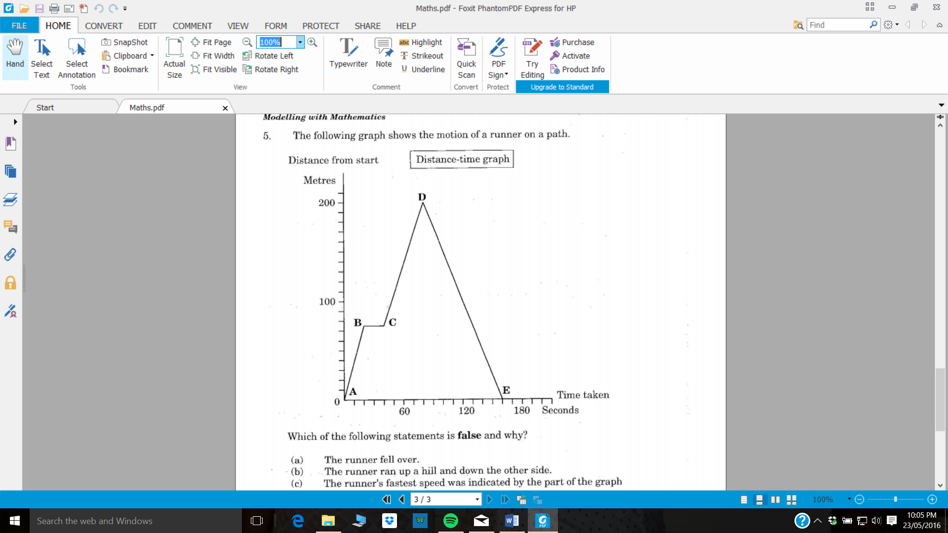

Which of the following statements is **false** and why?

1. The runner fell over.
2. The runner ran up a hill and down the other side.
3. The runner’s fastest speed was indicated by the part of the graph marked AB.
4. The runner’s average speed was the same as the speed indicated by the part of the graph marked DE.

Reason:\_\_\_\_\_\_\_\_\_\_\_\_\_\_\_\_\_\_\_\_\_\_\_\_\_\_\_\_\_\_\_\_\_\_\_\_\_\_\_\_\_\_\_\_\_\_\_\_\_\_\_\_\_\_\_\_\_\_\_\_

**Question 8 (7 marks: 2, 2, 1, 2)**

Mike, the plumber charges a $40 callout fee then $60 per hour. Alice’s Plumbing does not charge a callout fee but charges $80 per hour.

1. Complete the tables to show the costs over the first 5 hours:

Mike

|  |  |  |  |  |  |  |
| --- | --- | --- | --- | --- | --- | --- |
| **No. of hours** | **0** | **1** | **2** | **3** | **4** | **5** |
| **Cost** |  |  |  |  |  |  |

Alice

|  |  |  |  |  |  |  |
| --- | --- | --- | --- | --- | --- | --- |
| **No. of hours** | **0** | **1** | **2** | **3** | **4** | **5** |
| **Cost** |  |  |  |  |  |  |

1. Graph each of the plumbers’ fees on the grid below.

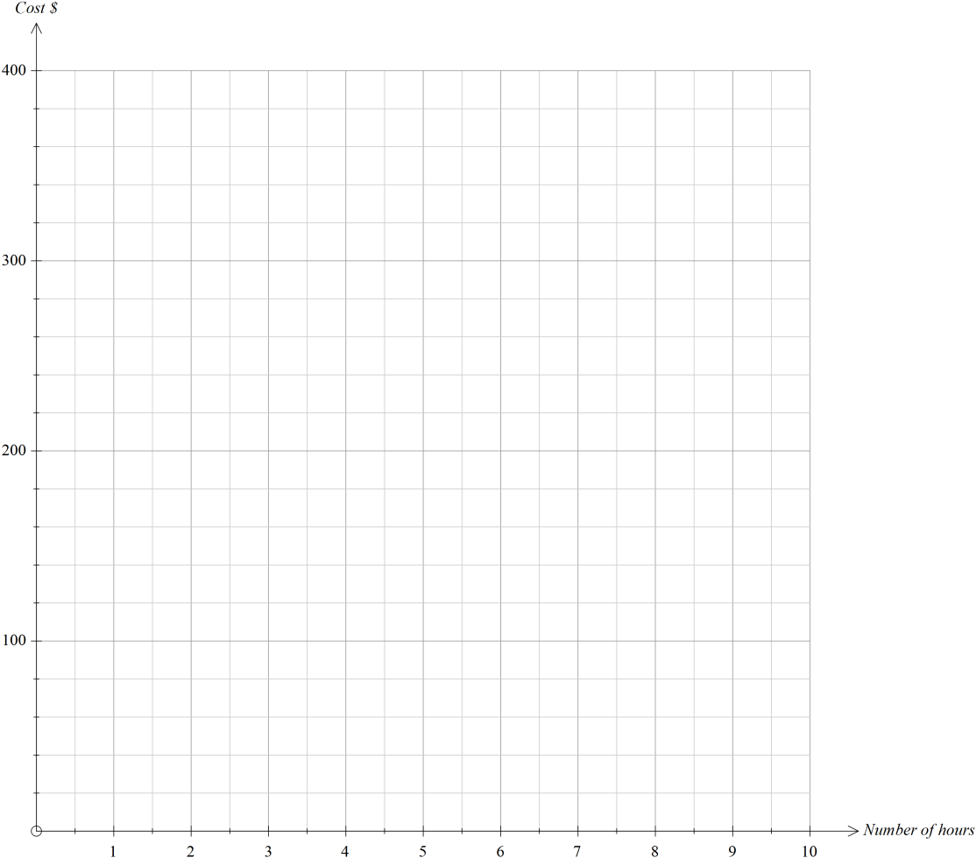

c) Which plumber would be cheaper if you had a job that lasted 10 hours?

d) Determine the co-ordinates of the intersection of the two graphs and comment on its significance in the context of this situation.

**Question 9 (5 marks: 3, 2)**

The number of babies born each year in Kojonup District Hospital is as follows:

|  |  |
| --- | --- |
| **Year** | **Number of babies** |
| 2004 | 35 |
| 2005 | 47 |
| 2006 | 51 |
| 2007 | 60 |
| 2008 | 58 |
| 2009 | 62 |
| 2010 | 46 |
| 2011 | 50 |
| 2012 | 45 |
| 2013 | 42 |
| 2014 | 39 |

1. Graph the data as a line graph on the grid provided below.

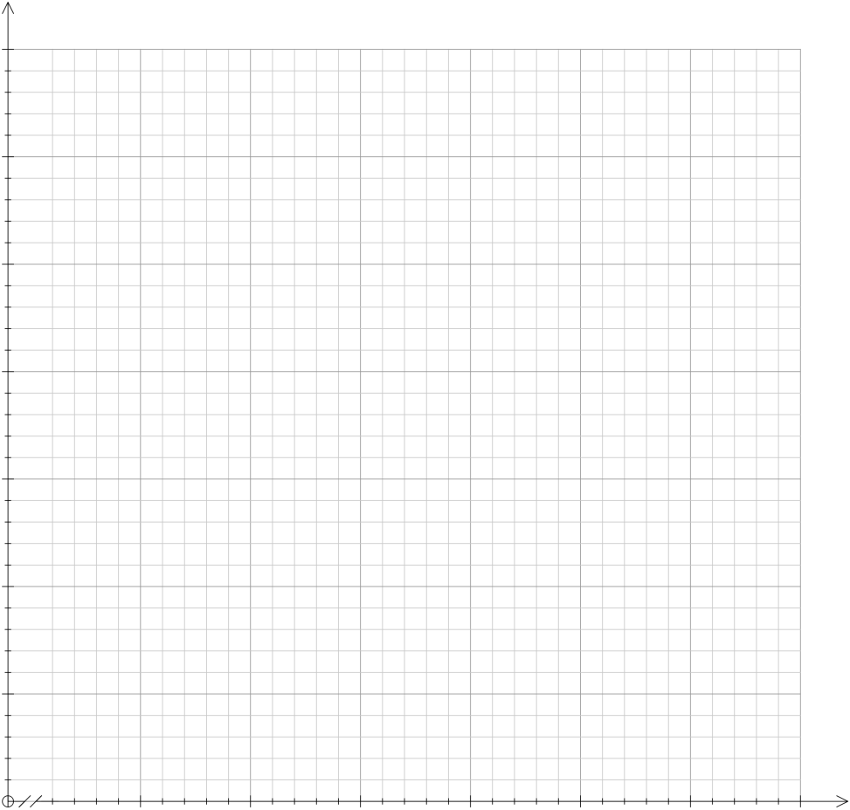

1. What comment can you make about the trend in the birth rate in this town?

**END OF TEST**